Anthony Sevarino

EET 2141

Fall ‘24

**Experiment 10 Field Effect Transistors – FET Amplifier Circuits**

**Introduction:**

The objective of this lab is to analyze junction field effect transistors, specifically, the interactions and behaviors of measurable data such as voltage and current across sources, gates, and drains within amplifier circuits. This study looks at two different common source amplifier circuits which use junction field effect transistors. The first of these circuits is simply contains four resistors, and a solid DC source. The second, both a DC and an AC source, as well as the addition of capacitors, which changes the behavior of the circuit noticeably. Note that the purpose of a JFET common source amplifier is to generate a voltage gain from a source which has a relatively high impedance along, which is useful when a high current gain is required from such an impedance input.

**Bench Parts and Equipment List:**

|  |  |  |  |
| --- | --- | --- | --- |
| ***Components*** |  |  |  |
| • | 1MΩ, 330kΩ, 4.7kΩ (x2), 10kΩ Resistors | • | JFET Transistor (2N5458) |
| •  ***Equipment*** | Numerous Connector Wires | • | 1uF (x2), 47uF Capacitors |
| • | Programmable DMM | • | ELENCO Trainer Board |
| • | Windows Machine w/  Multisim | • Triple Power Supply | | |  |
| • | Function Generator | • Oscilloscope | | | Windows Machine w/  Multisim |

**Discussion:**

# Part 1 – The Simulation

The first step of this lab is to construct the given circuit in Multisim, of which there are two for this specific study. The following is the provided image for each given circuit purposed toward the study of this lab

(See below)

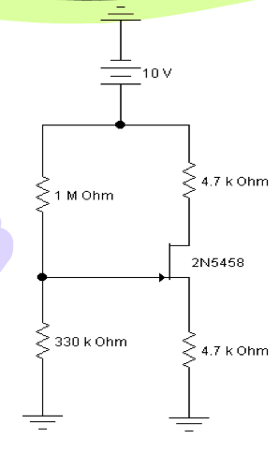

Figure - Circuit 1 Diagram Provided by Lab Manual

The constructed Multisim circuit is as follows:

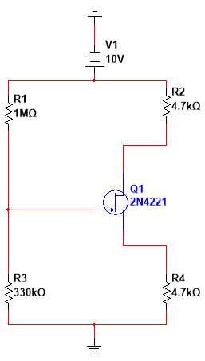Note that attached are both digital multimeters, as well as Multisim analysis probes used for obtaining simulation measurements (notably the probes are used for current measurements as to eliminate the requirement for disconnecting the circuit, while digital multimeters are used for voltage measurements as they can simply be connected in parallel).

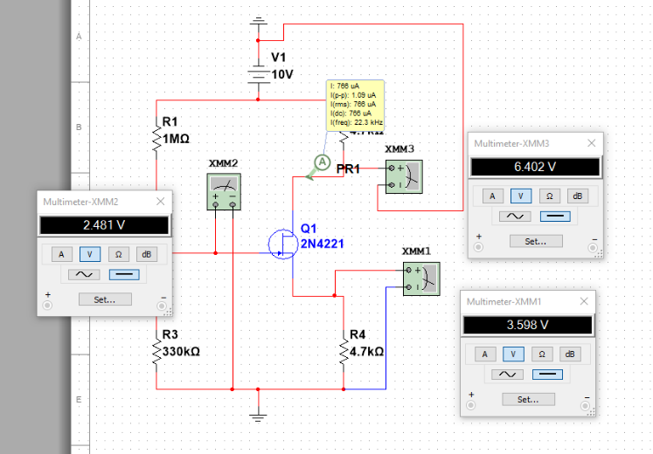

Figure 2 - Circuit 1 Constructed in Multisim

Viewing the resulting values of current and voltage throughout the circuit, it it is evident that the behavior of this circuit matches the original provided definition of a common source amplifier, which takes any signal and amplified the voltage through the drain.

Figure 3 - Circuit 1 Constructed in Multisim with data probes

Circuit 1 is a JFET series-parallel circuit, with a single transistor and 4 value-varying resistors. There is one DC 10V power sources. As stated before, this circuit functions as a common source amplifier, who’s purpose it is to increase the value of voltage. Applications such as those which obtain power from a high impedance source are examples of where a common source amplifier JFET would benefit. Note the orientation of the JFET (denoted by the arrow indicating the gate) is aligned with the bias of the current, which is known as *forward bias*.

The multimeter used to conduct testing was later changed to a multimeter following the capture of these images, in other words, the current probes appearing in the images was no longer used.

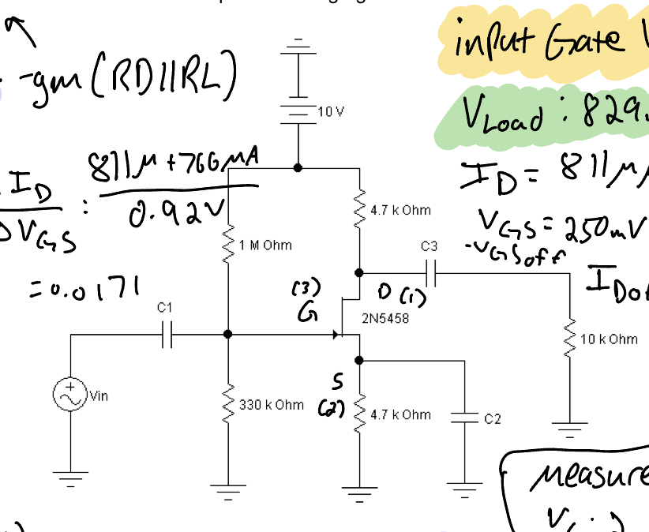Now, here is the second provided circuit for the study

Figure 2 - Circuit 2 Diagram Provided by Lab Manual

The constructed Multisim circuit is as follows:

Note that attached are both digital multimeters, as well as Multisim analysis probes used for obtaining simulation measurements (notably the probes are used for current measurements as to 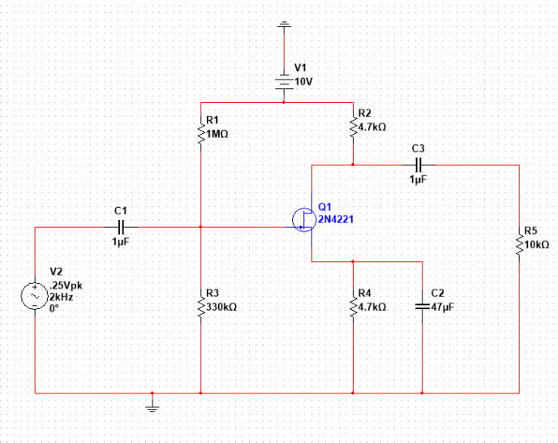eliminate the requirement for disconnecting the circuit, while digital multimeters are used for voltage measurements as they can simply be connected in parallel).

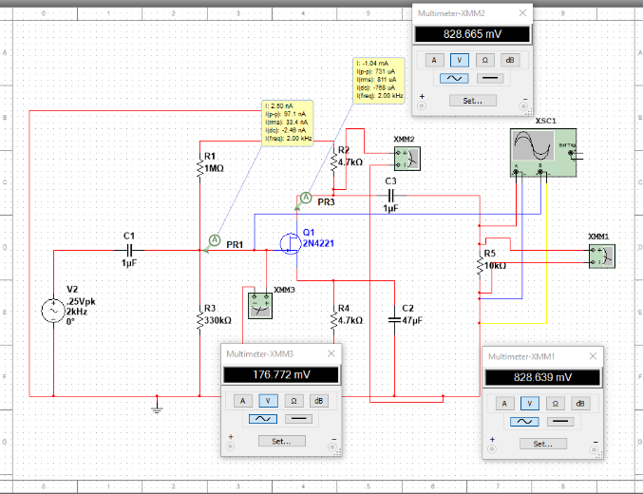

Figure 2 - Circuit 2 Constructed in Multisim

Viewing the resulting values of current and voltage throughout the circuit, it it is evident that the behavior of this circuit matches the original provided definition of a common source amplifier, which takes any signal and amplified the voltage through the drain.

Figure 3 - Circuit 2 Constructed in Multisim with data probes

Circuit 2 is a JFET series-parallel circuit, with a single transistor and 5 value-varying resistors. There is one DC 10V power source, and one 0.5vpp sinusoidal AC source. As stated before, this circuit functions as a common source amplifier, who’s purpose it is to increase the value of voltage. Applications such as those which obtain power from a high impedance source are examples of where a common source amplifier JFET would benefit. Note the orientation of the JFET (denoted by the arrow indicating the gate) is aligned with the bias of the current, which is known as *forward bias*.

The multimeter used to conduct testing was later changed to a multimeter following the capture of these images, in other words, the current probes appearing in the images was no longer used.

Below is the recorded waveform for both the load resistor voltage drop (blue) and the voltage at the gate (red).

Figure 5 – Waveform of Simulation Data

# Part 2 – The Bench

The circuit is now constructed on the bench, below are captures of each circuit constructed:

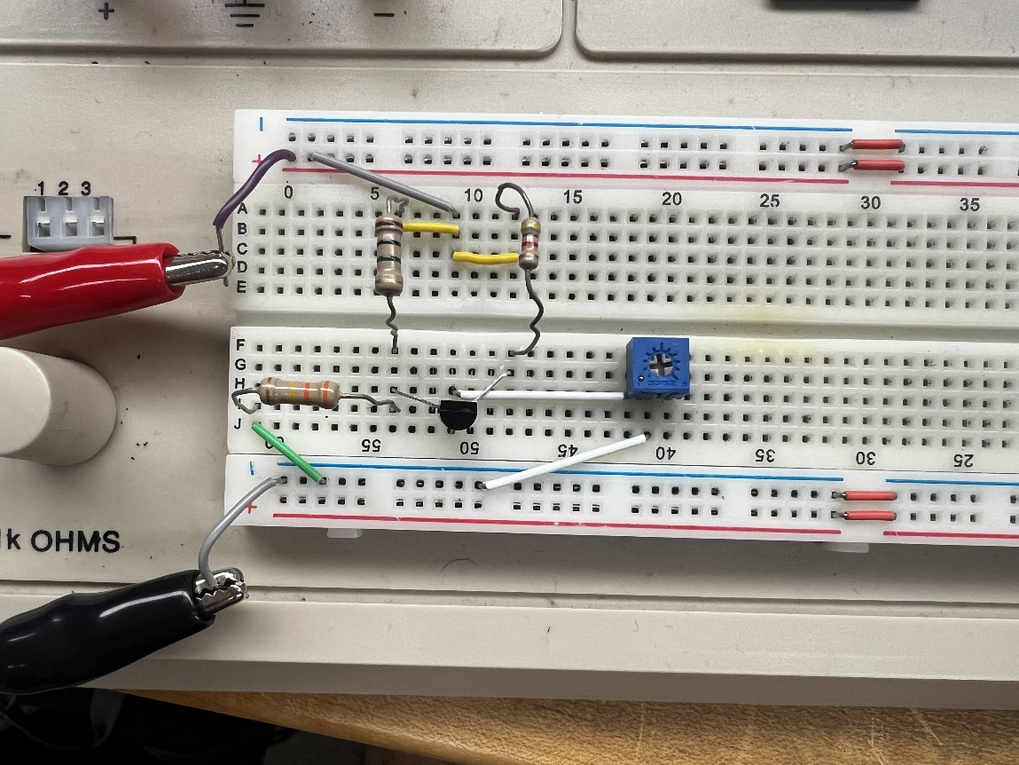

Figure 6 – Circuit 1 Constructed on the Bench

Note that above a potentiometer was used to simulate the value of a 4.7kΩ resistor, as supplies were short in the lab. The function generator is not yet needed in this circuit, and thus the only source of power is found on the left positive and negative buses, connected to a 10V DC source from the triple power supply.

The second circuit constructed on the bench:

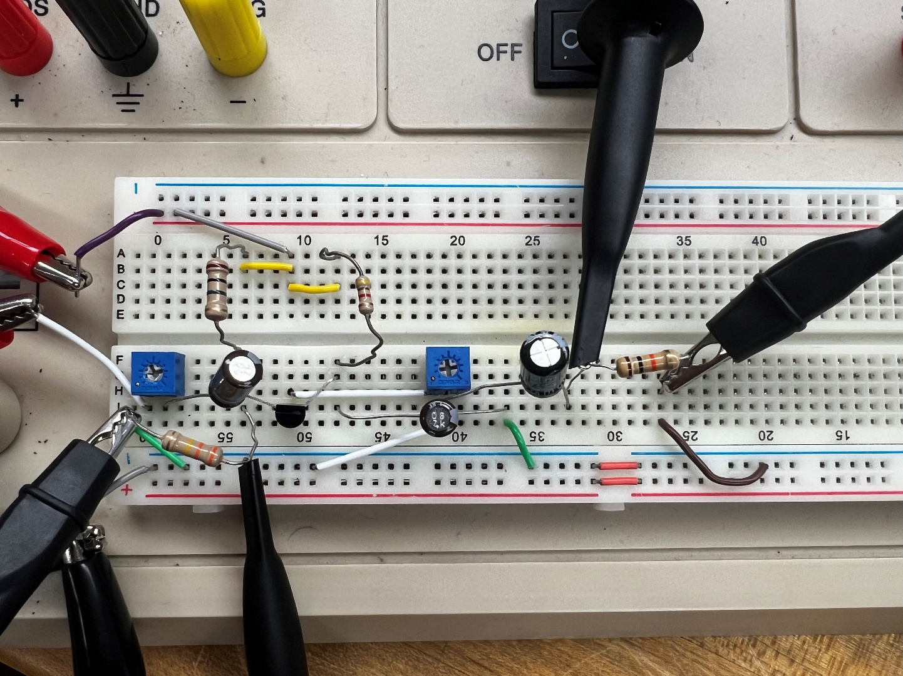

Figure - Circuit 2 constructed on the bench

Below is an analysis of the data obtained on the bench, compared to the found simulation data:

**Table 1 – Resistor Nominal and Measured Values**

|  |  |  |
| --- | --- | --- |
| **Resistor** | **Nominal** | **Measured** |
| **R1** | 1MΩ | 1.014kΩ |
| **R2** | 330kΩ | 337.48kΩ |
| **R3** | 4.7kΩ (1) | 4.668kΩ |
| **R4** | 4.7kΩ (2) | 4.681kΩ |

**Table 1 – Bench vs Simulation Data (Circuit 1)**

|  |  |  |
| --- | --- | --- |
|  | **Simulation** | **Bench** |
| **VG** | 2.48V | 2.509V |
| **VS** | 3.60V | 2.698V |
| **VD** | 6.40V | 7.367V |
| **Q Point** | -1.12,766E-6 | -1.34, 577E-6 |

The Q point was calculated using the following formula:

Where

**Table 2 – Bench vs Simulation Data (Circuit 2)**

|  |  |  |
| --- | --- | --- |
|  | **Simulation** | **Bench** |
| **VG** | 2.49V | 2.450V |
| **VLoad** | 829.0mV | 338.92mV |
| **Voltage Gain** | 54.67dB | 38.22dB |

The voltage gain was calculated using the following formula:

Where gm is the transconductance of the JFET, which is calculated as follows:

And RD represents the drain resistance, while the RL represents the load resistance

# Part 3 – The Comparison

Thus, it would appear that the bench measurements and simulation data both follow the same trend, and are relatively close in terms of values. Below is a graphical comparison of the two datasets:

Finally, for certification purposes, below the instructor sign-off can be found. As a reminder, this signature is obtained by either the course instructor or a certified lab assistant to ensure proper results are being obtained.

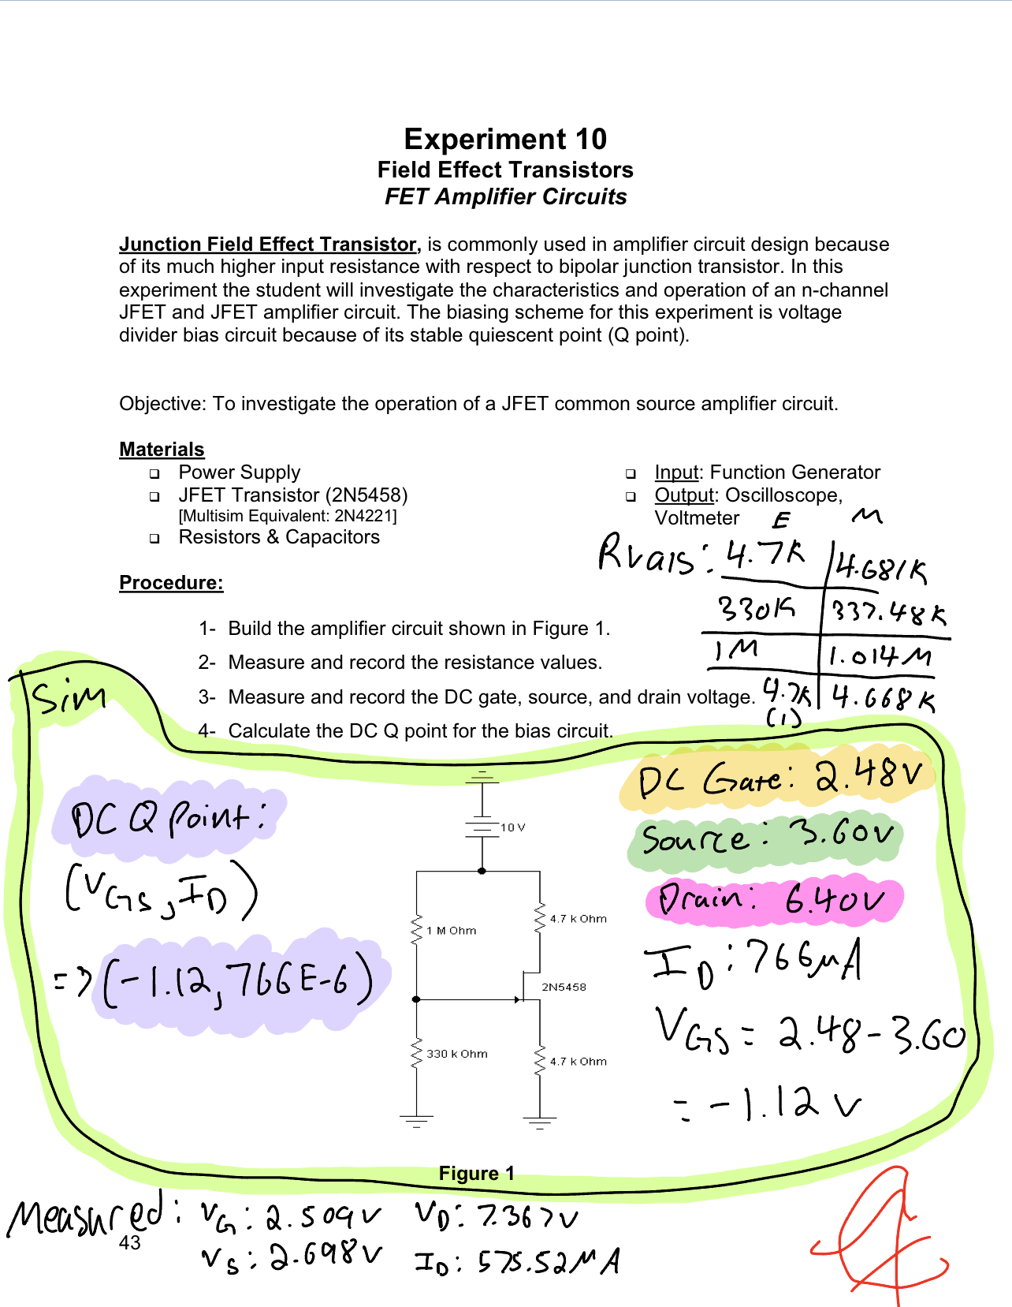

**Conclusion:**

The objective of this lab is to obtain an understanding and visualization of the behavior and purposes of JFETs in common source amplifier circuits. The particular behavior of this circuit is to increase the AC signal (which may have a high impedance) and amplify the voltage a moderate amount, alongside the current as well. Thus, the primary measurements being taken throughout the circuit will be voltage and current, however it is pertinent to test the resistance values of all resistors and components, as well as determining the input resistance of the AC source signal. While only two circuits are analyzed, and they are both common source amplifier circuits, there are variations which allow for a broader education and understanding of the circuit type. If this experiment were to be conducted again, it would be beneficial to observe other types of JFET based amplifier circuits, such as drain and gate amplifier circuits. That being said, the lab was conducted successfully based on the comparison of the data between simulation and bench measurements and subsequent data findings between simulation and bench experimentation, as they not only follow the same trends, but match data values closely.